 | 13.1.1 Editors - Shader Editor - Header - Tools and Options
Table of content
Introduction 2
Shader Type Drop-down Box 2
Object 2
World 2
Line Style 2
Object Context menu 2
Slot 2
List of materials 3
Add Material Slot 3
Remove Material Slot 3
Copy and Paste menu 3
Copy Material 3
Copy Material to Selected 3
Paste Material 3
Remove unused Slots 3
Move Material Up / Down 3
Assign 3
Select 3
Deselect 4
Search Field 4
Material Prop 4
Material Browser 4
New 4
Material edit box 4
Fake User 4
Clear Asset 4
New 4
Remove 5
Right Click menus 5
Options 5
Use Nodes 5
Pin (pin icon) 5
Snap 5
Node Editor Overlays 5
Show Overlays 5
Wire Colors 5
Reroute Auto Labels 6
Context Path 6
Annotations 6

Introduction

The header in the Shader editor contains various menus and tools. This chapter here is about the tools, modes and options elements in the header.
The text menus are covered in a own chapter each. They vary too much, dependent of mode and object type.

Shader Type Drop-down Box

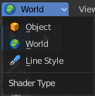
The Mode drop-down box allows you to switch between the different shader type modes. An object has a different set of available shaders than the world or a line style shading.

Object
In this mode you work with the scene objects and its materials.

World
In this mode you work with the world settings. HDRI's for example.

Line Style
In this mode you work with Freestyle renderer materials.

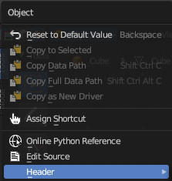
Object Context menu
When you right click at the dropdown box then you will reveal the Object context menu.

Slot
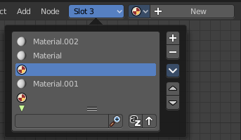
This element just exists in Object mode.

The Slot menu displays the assigned material(s) at the current active mesh. It can be used to select the active material on the active object. And to select or assign materials to different mesh parts of the same object.
When you add a material by clicking at the new button in the material prop, or by choosing another material from the materials browser, then it is usually also added or changed in the slot system in the current position.
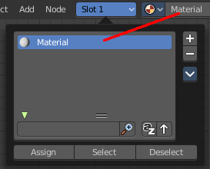

List of materials
The list of materials in the slot list.

Add Material Slot
Adds a new material slot. When you do this manually then this slot will be empty.

Remove Material Slot
Remove the selected material slot. The removed material will not longer be part of the currently active mesh.

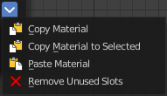
Copy and Paste menu
Copy and paste materials. But just at the current active mesh. Means in Edit Mode.

Copy Material
Copies the currently selected material

Copy Material to Selected
Copies the currently selected material, and pastes it to the selection

Paste Material
Pastes the material.

Remove unused Slots
Clean up unused slots.

Move Material Up / Down
Moves the selected material up or down in the list.

Assign
This button appears when you are in Edit mode in the 3D view. Assign the selected material to the selected geometry.

Select
This button appears when you are in Edit mode in the 3D view. Select the geometry where this material is assigned to.

Deselect
This button appears when you are in Edit mode in the 3D view. Deselects the geometry where this material is assigned to.

Search Field
When you click at the little triangle button below the list then you can reveal a search element. The buttons should be self explaining. So we won't go into detail here.

Material Prop

Create a new material, and see a list of the available materials in the scene.

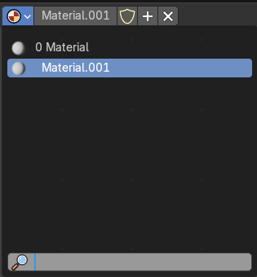
Material Browser
The list of available materials in the scene.

New
Creates a new material.

Material edit box
The name of the current active material. Here you can also rename the material.
Note that the name and available materials differs, dependent in which mode you are. In Object mode you will see the object materials. In World mode the world materials. And in Line Style mode the materials for Freestyle rendering.

Fake User
Wit this button you assign a fake user to this selected image.
Data, like images, that is not longer linked to anything else gets removed when you save and reload a scene. Bforartists has the concept of fake users to go around this behavior. An image with a fake user is in fact linked to something. And so it is not lost when you save and reload the scene.

Clear Asset
When you have marked the material as asset, then the fake user button is replaced by a Clear Asset button. It allows you to clear the asset.

New
Creates a new material.

Remove
Removes the material. To delete it completely you need to purge it. See Fake user.

Right Click menus
When you right click at the material property then you will reveal context menus with different content, dependant of where you click. Most of the content is explained in chapter 6, the general right click menu functionality. The rest should be self explaining.

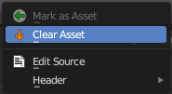
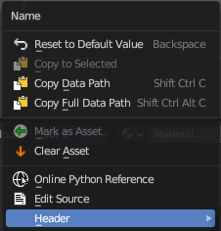
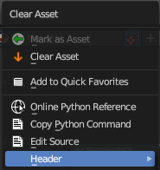
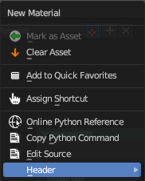

Options

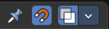
At the right side you will see some options.

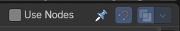
Use Nodes
The Use Nodes setting is mostly a legacy setting. And displays just in Line Style mode.

Pin (pin icon)
The pin button will keep the current material selection fixed. When a material is pinned, it will remain visible in the shader editor even when another object or material is selected elsewhere.

Snap
Activates snapping.

Node Editor Overlays
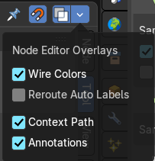
Activates the node editor overlays. When the tool is activated, then you will also overlays settings in the editor. The drop down arrow to the right shows different overlay types.

Show Overlays
Show or hide the overlays.

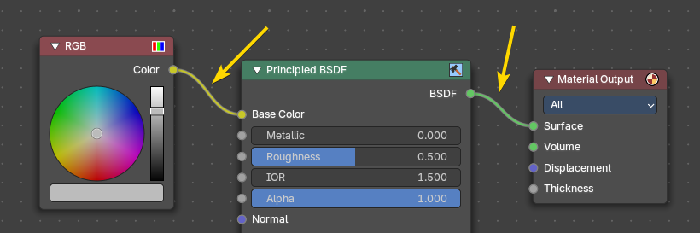
Wire Colors
Color node links based on their connected sockets.
Example: The color RGB socket is yellow that makes a yellow line, and the Shader BSDF socket is green that makes a green line.

Reroute Auto Labels
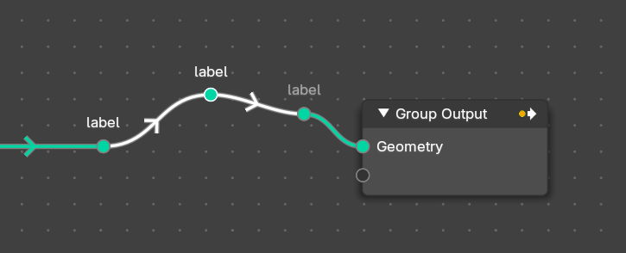
Label reroute nodes based on the label of connected reroute nodes.
Example: The first reroute label to the right has concurring reroute labels down the line. If you toggle this off, the concurring reroute labels down the line won’t contain labels.

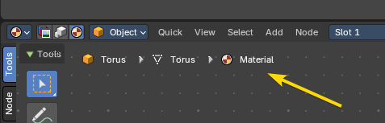
Context Path
Display breadcrumbs for the editor’s context.

Annotations
Shows annotations for this editor view that have been drawn by the annotation tool.

